HOME PAGE
<html>
<head>
<title>Ticket Booking</title>
</head>
<body style="background-color:FFEDFC">
<marquee><h1><center>TICKET BOOKING</center></h1></marquee>
<h2><i>THIS IS THE TICKET RESERVATION PAGE</i></h2>
<p>This is the Ticket Reservation Page. It is the official webpage where users can book and reserve their tickets easily.</p>
<a href ="file:///Z:/html/ex1/p1.html">Ticket Booking</a><br>
<a href ="file:///Z:/html/ex1/p2.html">Event Booking </a><br>
<a href ="file:///Z:/html/ex1/p3.html">Bus booking</a><br>
<a href ="file:///Z:/html/ex1/p4.html">Train Booking</a><br>
</body></html>
MOVIE TICKET
<html>
<head>
<title>Ticket Booking</title>
</head>
<body style="background-color:EBECFC">
<h1><i/><center>AVAILABLE TICKETS & MOVIES</center></i></h1>
<center>
<img src="cinema.jfif" width="400" height="200">
</center>
<table border="1" width="30%" height="50">
<caption>Live Cinema Booking Status</caption>
<tr>
<th>Movie Name</th>
<th>Seat Available</th>
</tr>
<tr><td>Alchemy</td>
<td>130 Seats</td></tr>
<tr><td>Stranger things</td>
<td>45 Seats</td></tr>
<tr><td>Murder</td>
<td>50 Seats</td></tr>
<tr><td>Voice</td>
<td>70 Seats</td></tr>
</table>
<h2><i><center>LEARN ABOUT THE EVENT DETAILS</center></i></h2>
<ul><li><b>Venue:</b> D cenima Hall C</li>
<li><b>Date:</b> March 15, 2026</li>
<li><b>Entry Fee:</b> $400</li></ul>
<ol><li>Doors Open & Registration (10:00 AM)</li>
<li>Online Registration available </li>
<li>Total Three Shows</li>
<li>Lunch & Networking Break (1:00 PM)</li></ol>
<h2><i><center>MOVIE TICKET RESERVATION</center></i></h2>
<form action="/submit-reservation" method="POST">
<p><label>Full Name:</label><br>
<input type="text" name="customer_name" required></p>
<p><label>Email Address:</label><br>
<input type="email" name="customer_email" required></p>
<p><label>Select Movie:</label><br>
<select>
<option value="">Choose a Movie</option>
<option value="alchemy">Alchemy</option>
<option value="stranger_things">Stranger Things</option>
<option value="murder">Murder</option>
<option value="voice">Voice</option>
</select>
<label><br>Show time:</label><br>
<select><option value="">Choose a Time</option>
<option value="alchemy">1st Show (10:10)</option>
<option value="1st Show (2:10)">Stranger Things</option>
<option value="murder">1st Show (6:10)</option>
<option value="voice">1st Show (11:10)</option></select>
</p>
<p><input type="submit" value="Book Tickets Now"></p>
</body></html>
EVENT BOOKING
<html>
<head>
<title>Event Booking</title>
</head>
<body style="background-color:EBFCEE">
<h1><center><i>AVAILABLE EVENTS & SEATS</i></center></h1>
<center>
<img src="concet.jfif" " width="400" height="200">
</center>
<table border="1" width="40%" height="50">
<caption>Live Event Booking Status</caption>
<tr><th>Event Name</th>
<th>Seats Available</th></tr>
<tr><td>Music Concert</td>
<td>200 Seats</td></tr>
<tr><td>Tech Conference</td>
<td>150 Seats</td></tr>
<tr><td>Art Exhibition</td>
<td>100 Seats</td></tr>
<tr><td>Drama Show</td>
<td>80 Seats</td></tr>
</table>
<h2><i><center>EVENT DETAILS</center></i></h2>
<ul><li><b>Venue:</b> Mugula Hall D</li>
<li><b>Date:</b> March 15, 2026</li>
<li><b>Entry Fee:</b> $400</li></ul>
<ol><li>Doors Open & Registration (10:00 AM)</li>
<li>Online Registration Available</li>
<li>Multiple Sessions Throughout the Day</li>
<li>Lunch & Networking Break (1:00 PM)</li></ol>
<h2><i><center>EVENT TICKET RESERVATION</center></i></h2>
<form action="/submit-reservation" method="POST">
<p><label>Full Name:</label><br>
<input type="text" name="customer_name" required></p>
<p><label>Email Address:</label><br>
<input type="email" name="customer_email" required></p>
<p><label>Select Event:</label><br>
<select name="event_name" required>
<option value="">Choose an Event</option>
<option value="music_concert">Music Concert</option>
<option value="tech_conference">Tech Conference</option>
<option value="art_exhibition">Art Exhibition</option>
<option value="drama_show">Drama Show</option>
</select></p>
<p><label>Session Time:</label><br>
<select name="session_time" required>
<option value="">Choose a Time</option>
<option value="morning">Morning Session (10:00 AM)</option>
<option value="afternoon">Afternoon Session (2:00 PM)</option>
<option value="evening">Evening Session (6:00 PM)</option>
</select></p>
<p><input type="submit" value="Book Event Tickets Now"></p>
</form></body></html>
BUS RESERVATION
<html>
<head>
<title>Bus Reservation</title>
</head>
<body style="background-color:F6FCEB">
<h1><center><i>AVAILABLE TICKETS & BUS ROUTES</i></center></h1>
<center>
<img src="bus.jfif" width="400" height="200">
</center>
<table border="1" width="30%" height="50">
<caption>Live Bus Ticket Booking Status</caption>
<tr><th>Bus Route</th>
<th>Seat Available</th></tr>
<tr><td>Route A (City Center)</td>
<td>130 Seats</td></tr>
<tr><td>Route B (Expressway)</td>
<td>45 Seats</td></tr>
<tr><td>Route C (Night Rider)</td>
<td>50 Seats</td></tr>
<tr><td>Route D (Coastal Way)</td>
<td>70 Seats</td></tr>
</table>
<h2><i><center>BUS TICKET RESERVATION</scenter></i></h2>
<form action="/submit-reservation" method="POST">
<p><label>Full Name:</label><br>
<input type="text" name="customer_name" required></p>
<p><label>Email Address:</label><br>
<input type="email" name="customer_email" required></p>
<p><label>Select Bus Route From:</label><br>
<select>
<option value="">Pick up At</option>
<option value="Central Madurai">Central Madurai</option>
<option value="Main Road">Main Road</option>
<option value="Trichy">Trichy</option>
<option value="Ramnad">Ramnad</option>
</select>
<label><br>Show time:</label><br>
<select><option value="">Destrination</option>
<option value="Chennai">Chennai</option>
<option value="Covai">Covai</option>
<option value="Pondi">Pondi</option>
<option value="Sellem">Sellem</option></select></p>
<p><label>Ticket Type:</label><br>
<input type="radio" name="ticket_type" value="One Way" required> One Way
<input type="radio" name="ticket_type" value="Return"> Return</p>
<p><input type="submit" value="Book Tickets Now"></p>
</body></html>
TRAIN RESRVATION
<html>
<head>
<title>Train Reservation</title>
</head>
<body style="background-color:FCF1EB">
<h1><center><i>AVAILABLE TICKETS & TRAIN ROUTES</i></center></h1>
<center>
<img src="train.jfif" width="400" height="200">
</center>
<table border="1" width="40%" height="50">
<caption>Live Train Ticket Booking Status</caption>
<tr><th>Train Route</th>
<th>Seats Available</th></tr>
<tr><td>Route A </td>
<td>200 Seats</td></tr>
<tr><td>Route B </td>
<td>120 Seats</td></tr>
<tr>
<td>Route C
</td>
<td>80 Seats</td>
</tr>
<tr>
<td>Route D </td>
<td>150 Seats</td>
</tr>
</table>
<h2><i><center>TRAIN TICKET RESERVATION</center></i></h2>
<form action="/submit-reservation" method="POST">
<p>
<label>Full Name:</label><br>
<input type="text" name="customer_name" required>
</p>
<p>
<label>Email Address:</label><br>
<input type="email" name="customer_email" required>
</p>
<p><label>Select Departure Station:</label><br>
<select name="departure_station">
<option value="">Choose Departure</option>
<option value="Madurai">Madurai</option>
<option value="Trichy">Trichy</option>
<option value="Chennai">Chennai</option>
<option value="Covai">Covai</option>
</select></p>
<p><label>Select Arrival Station:</label><br>
<select name="arrival_station">
<option value="">Choose Arrival</option>
<option value="Bangalore">Bangalore</option>
<option value="Hyderabad">Hyderabad</option>
<option value="Delhi">Delhi</option>
<option value="Mumbai">Mumbai</option>
</select></p>
<p>
<label>Ticket Type:</label><br>
<input type="radio" name="ticket_type" value="One Way"> One Way
<input type="radio" name="ticket_type" value="Return"> Return
</p>
<p>
<label>Additional Preferences:</label><br>
<input type="checkbox" name="preferences" value="Window Seat"> Window Seat<br>
<input type="checkbox" name="preferences" value="Meal Service"> Meal Service<br>
<input type="checkbox" name="preferences" value="Extra Luggage"> Extra Luggage<br>
</p>
<p>
<input type="submit" value="Book Train Tickets Now">
</p>
</form>
</body>
</html>

HOME PAGE

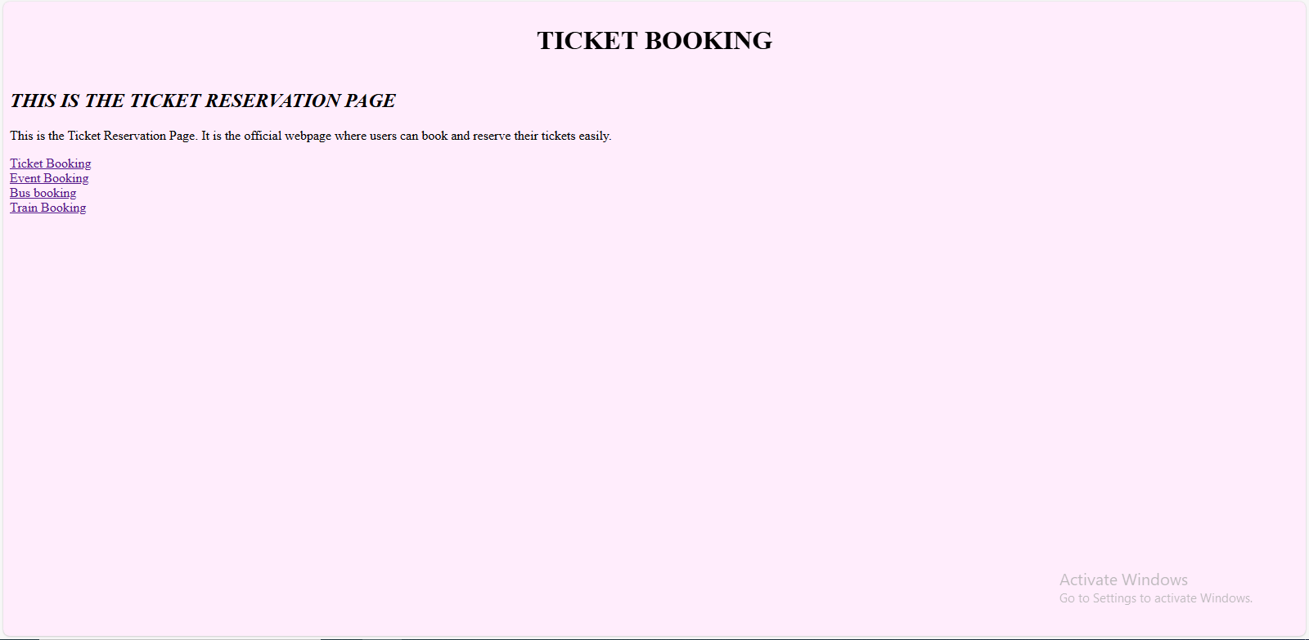

TICKET BOOKING

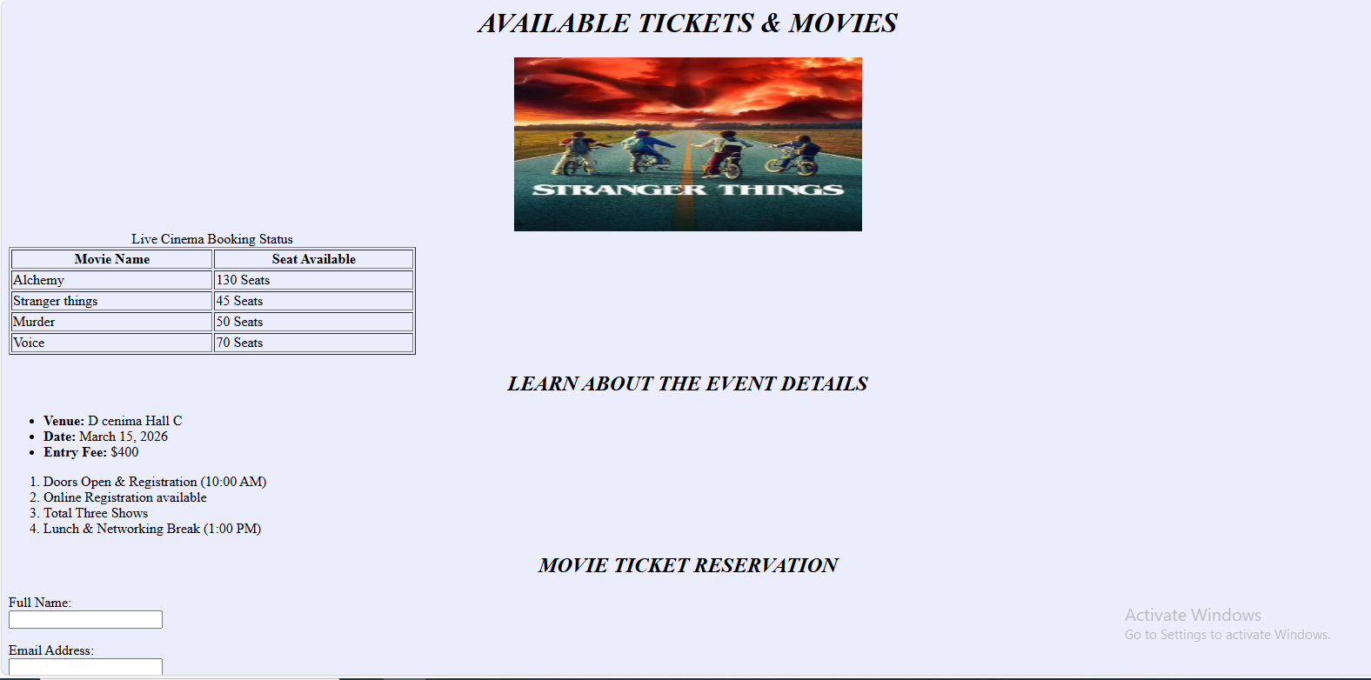

EVENT BOOKING
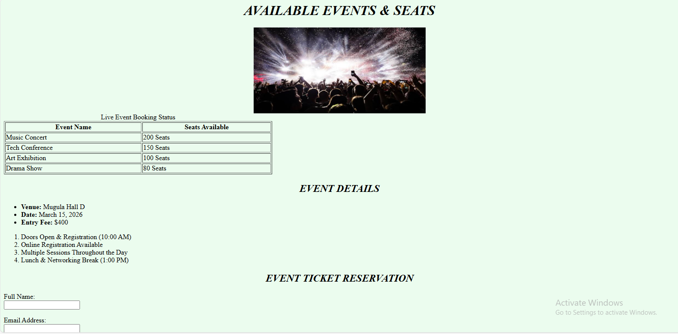

BUS BOOKING

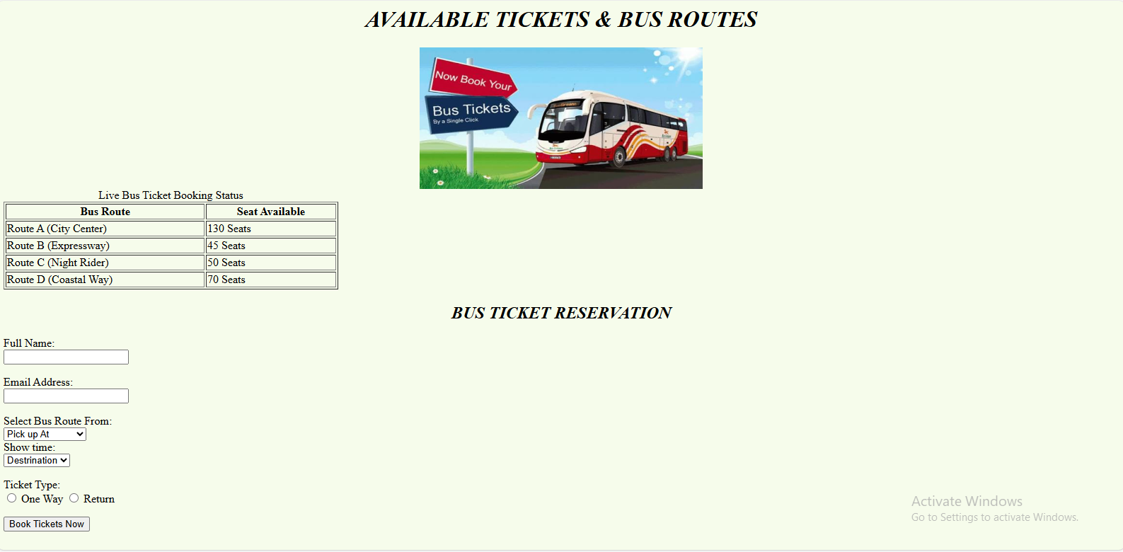

TRAIN BOOKING 